**Task 1:**

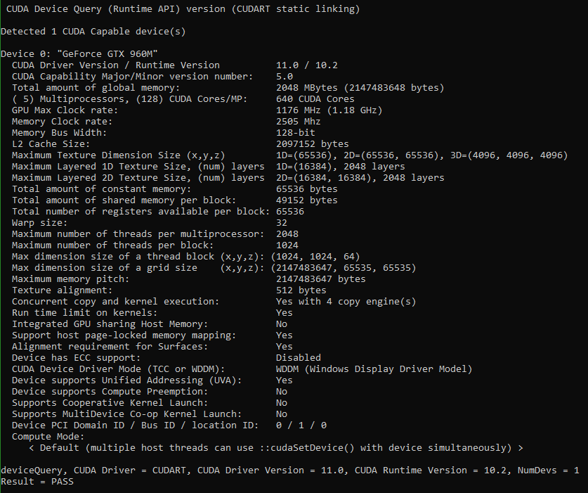

* GPU Devices = 1
* Total amount of shared memory per thread block = 49152 bytes
* Max dimension size of a thread block (x, y, z) = (1024, 1024, 64)
* Max number of registers available per thread block = 65536
* Global memory size = 2048 Mbytes

**Task 2:**

I could not get the code to work correctly. This is my best attempt. I understand that the GPU is supposed to be significantly faster than the CPU.

CPU Time:



GPU Time:



